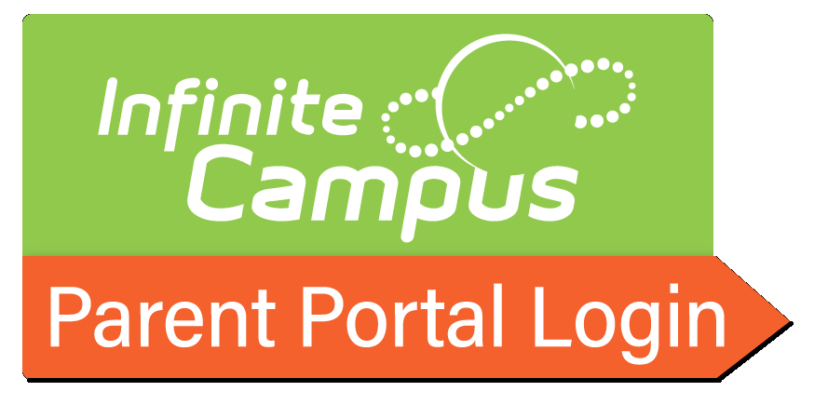

* [Parent Portal "Creating a Parent Campus Account" Video](https://rcboe.instructuremedia.com/embed/a0ffd886-081c-4342-a7ce-2390903fbaae)

<https://rcboe.instructuremedia.com/embed/a0ffd886-081c-4342-a7ce-2390903fbaae>

* [Parent Portal Activation Key Lookup](https://campus.rcss-k12.org/campus/K12_Custom/cParent/index.jsp?appName=richmond)

<https://campus.rcss-k12.org/campus/K12_Custom/cParent/index.jsp?appName=richmond>

* [Parent Portal Log-in](https://campus.rcss-k12.org/campus/portal/richmond.jsp?)

<https://campus.rcss-k12.org/campus/portal/richmond.jsp>?

* [Parent Portal Written Instructions with Pictures](https://www.rcboe.org/cms/lib/GA01903614/Centricity/Domain/4/RCSS%20Parent%20Portal%20Registration%20Instructions.pdf)

<https://www.rcboe.org/cms/lib/GA01903614/Centricity/Domain/4/RCSS%20Parent%20Portal%20Registration%20Instructions.pdf>